KARNATAK LAW SOCIETY’S

GOGTE INSTITUTE OF TECHNOLOGY

UDYAMBAG, BELAGAVI-590008

(An Autonomous Institution under Visvesvaraya Technological University, Belagavi)

**(APPROVED BY AICTE, NEW DELHI)**



*Course Activity Report*

Design and implement Push Down Automata a simulator that is capable of accepting a description of a context free language and then executing that machine against a set of strings, reporting back for each whether or not the string is accepted by the machine. L= { an b2n for n >=1 }  
*Submitted in the partial fulfillment for the academic requirementof*

***5th Semester B.E.***

***in***

**Formal Language and Automata Theory**

*Submitted by*

**Aditya Goswami 2GI18CS008**

**Ashutosh Kumar Bharti 2GI18CS032**

**Himanshu Kumar 2GI18CS055**

**Kalpak Bagi 2GI18CS061**

**GUIDE**

**Dr. Mallikarjun M.Math**

**PROFESSOR**

**2020 – 2021**

**Course Seminar report and ppt content**

**Marks allocation:**

|  |  |  |  |  |  |  |
| --- | --- | --- | --- | --- | --- | --- |
|  | Batch No. : | | | | | |
| 1. | Seminar Title: | Marks Range | USN | | | |
| 2GI18CS123 | 2GI18CS127 | 2GI18CS132 | 2GI18CS138 |
| 2. | Abstract (PO2) | 0-2 |  |  |  |  |
| 3. | Application of the topic to the course (PO2) | 0-3 |  |  |  |  |
| 4. | Literature survey and its findings (PO2) | 0-4 |  |  |  |  |
| 5. | Methodology, Results and Conclusion (PO1,PO3,PO4) | 0-6 |  |  |  |  |
| 6. | Report and Oral presentation skill (PO9,PO10) | 0-5 |  |  |  |  |
|  | Total | 20 |  |  |  |  |

**\* 20 marks is converted to 10 marks for CGPA calculation**

**1.Engineering Knowledge:** Apply the knowledge of mathematics, science, engineering fundamentals and an engineering specialization to the solution of complex engineering problems.

**2.Problem Analysis:** Identify, formulate, review research literature, and analyze complex engineering problems reaching substantiated conclusions using first principles of mathematics, natural sciences and Engineering sciences.

**3.Design/Development of solutions:**Design solutions for complex engineering problems and design system components or processes that meet the specified needs with appropriate consideration for the public health and safety, and the cultural, societal, and environmental considerations.

**4.Conduct investigations of complex problems:** Use research-based knowledge and research methods including design of experiments, analysis and interpretation of data, and synthesis of the information to provide valid conclusions.

**5.Modern tool usage:**Create, select, and apply appropriate techniques, resources, and modern engineering and IT tools including prediction and modeling to complex engineering activities with an understanding of the limitations.

**6.The engineer and society:**Apply reasoning informed by the contextual knowledge to assess societal, health, safety, legal and cultural issues and the consequent responsibilities relevant to the professional engineering practice.

**7.Environment and sustainability:** Understand the impact of the professional engineering solutions in societal and environmental contexts, and demonstrate the knowledge of, and need

for sustainable development.

**8.Ethics:** Apply ethical principles and commit to professional ethics and responsibilities and norms of the engineering practice.

**9.Individual and team work:** Function effectively as an individual and as a member or leader in diverse teams, and in multidisciplinary settings.

**10.Communication:** Communicate effectively on complex engineering activities with the engineering community and with society at large, such as, being able to comprehend and write effective reports and design documentation, make effective presentations, and give and receive clear instructions.

**11. Project management and finance:** Demonstrate knowledge and understanding of the engineering management principles and apply these to one's own work, as a member and leader in a team, to manage projects and in multidisciplinary environments.

**12. Life-long learning:** Recognize the need for and have the preparation and ability to engage in independent and lifelong learning in the broadest context of technological change.

# problem statement

Design and implement Push Down Automata a simulator that is capable of accepting a description of a context free language and then executing that machine against a set of strings, reporting back for each whether or not the string is accepted by the machine. L= { an b2n for n >=1 }

transition function

δ(q0, a ,z)=(q0, az)

δ(q0, a, a)=(q0, aa)

δ(q0, b, a)=(q1,a)

δ(q1, b, a)=(q2, ε)

δ(q2, b, a)=(q1, a)

δ(q2, ε, z)=(qf, z)

Transition Diagram

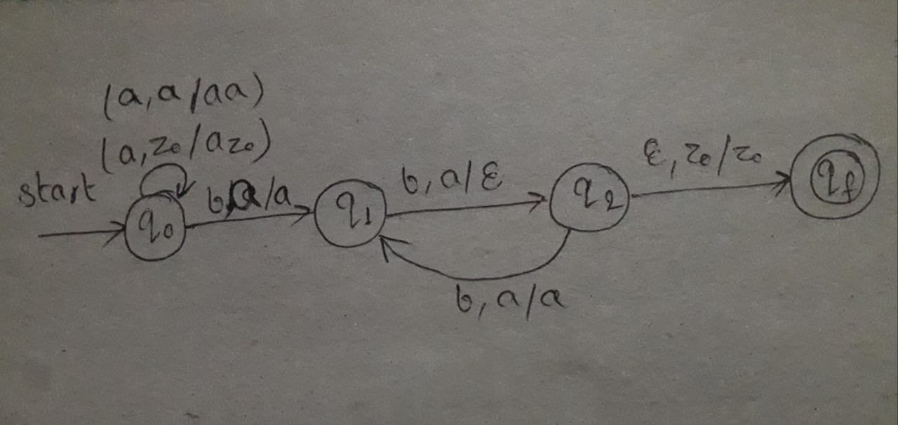

**Programm:-**#include<stdio.h>

#include<string.h>

int top=-1;

char s[10];

void push()

{

s[top++]='A';

}

void pop()

{

--top;

}

int main()

{

int i,n;

char a[20];

// int m = 20;

printf("\nProgram For PDA Which accepts Strings Of (a^n)(b^2n)\n");

printf("\nEnter String::");

gets(a);

n=strlen(a);

top=-1;

for(i=0;i<n;i++)

{

if(a[0]=='b')

{

top=6;

}

else{

if(a[i]=='a' || a[i]=='b')

{

if(a[i]=='a' && a[i-1]!= 'b')

{

push();

push();

}

else

{

pop();

}

}

else

{

break;

}

}

}

if(top==-1)

{

printf("\nString Accepted.\n");

}

else

{

printf("\nString Rejected.\n");

}

}  
  
output:-  
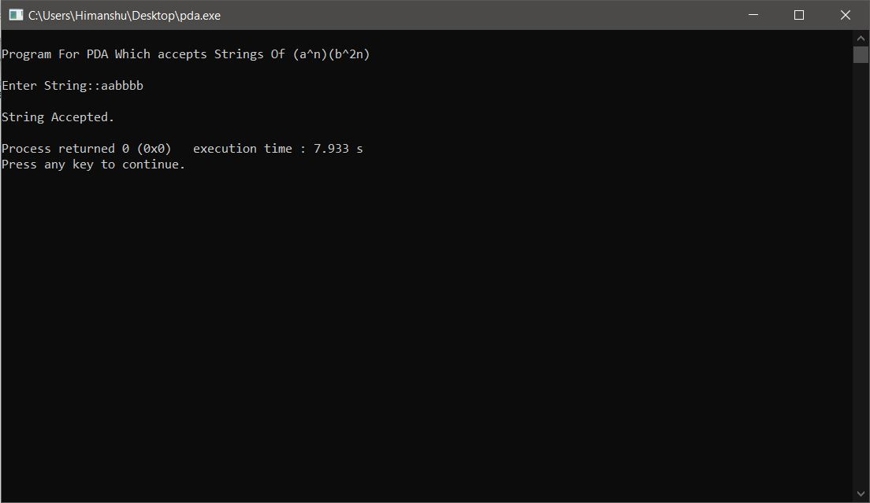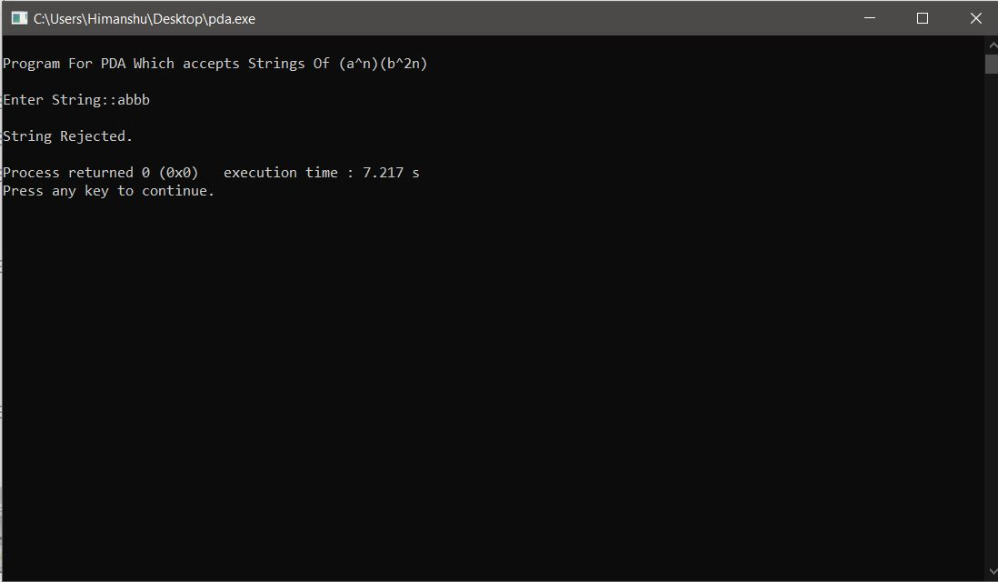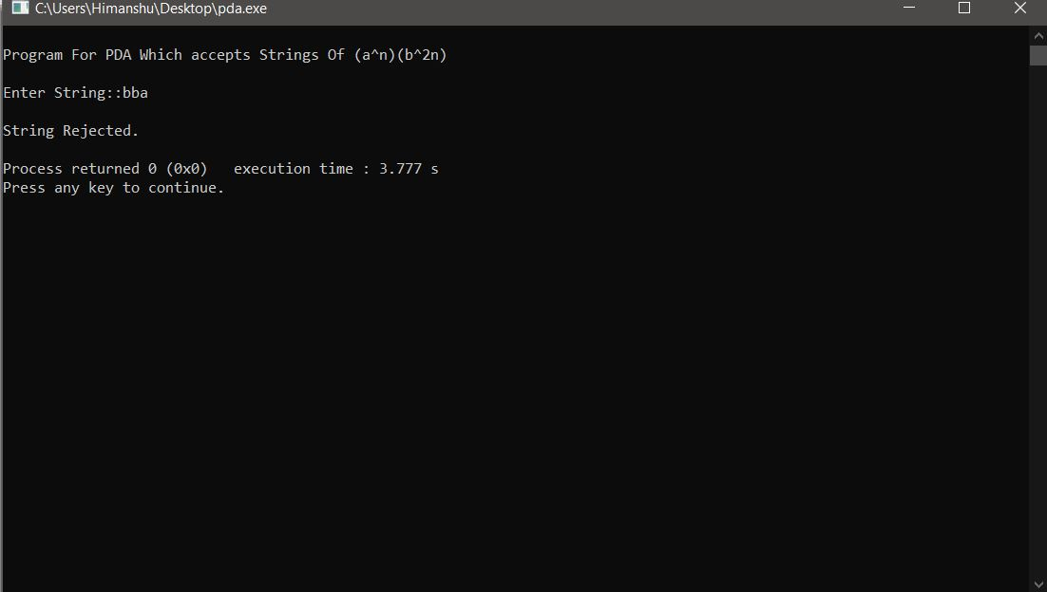

**REFERENCE**

* 1. [**https://www.geeksforgeeks.org/**](https://www.geeksforgeeks.org/)